IT1394 Visual Analytics Project

Final Report

|  |  |
| --- | --- |
| Module Group: | IT1394-01 |
| Tutor: | Ms Wang |
| Group Member 1: | Chong Cheng Hock | 230643M |
| Group Member 2: | Choo Tze Hsuen | 220926F |
| Group Member 3: | Cheng Sheh Nee | 234745J |
| Group Member 4: | Teagan Tham | 232142G |
| Submission Date: | 18 Feb 2024 |

# Table of Contents

1. Executive Summary
2. Project Plan

2.1) Project Schedule and Task Allocation

2.2) Software Tools Used in Project

1. Data Understanding, Visualisation, and Modelling
2. Iteration Log
3. Problems Encountered
4. Future Enhancements
5. Conclusions
6. Recommendations

# 1. Executive Summary

“Singapore is committed in developing a sustainable country in the future” - How true is this?

We used various indicators in tangent to the sustainability goals set in Singapore Green Plan 2030 as a basis of comparison. We selectively focused on the 4 pillars – City in Nature, Energy Reset, Sustainable Living, and Resilient future. Employed metrics include tree cover loss, agriculture orientation index, recycling rates, electricity usage nationwide, etc.

The visualisations serve as analytical tools to help highlight over-achieving as well as underperforming areas where the government has deployed solutions targeting our stakeholders – Citizens who have lived in Singapore for more than 10 years.

Singapore is committed to developing feasible solutions to meet its sustainability goals as part of the Singapore Green Plan 2030. However, it can look more into the effectiveness of the solutions, and if they even contribute to the long-term goal of achieving sustainability.

Recognising and addressing the bottlenecks in this report can help Singapore strive towards its sustainability goals quicker and more efficiently.

The indicators and analysis presented show that the government is committed to developing a sustainable country in the future, with room for many improvements.

# 2. Project Plan

## 2.1 Project Team Organisation

The team consisted of Chong Cheng Hock, Choo Tze Hsuen, Teagan Tham, and Cheng Sheh Nee.

Everyone had an influential impact on this report, essentially team leaders.

## 2.2 Project Schedule and Task Allocation

To keep track of our progress, we employed a Gantt Chart-based project schedule.

|  |  |
| --- | --- |
| **Description** | **Screen Capture** |
| Project Schedule (Gantt Chart) |  |

## 2.3 Software Tools Used in Project

Below is a complication of the resources utilised in crafting our analysis/solution:

|  |  |
| --- | --- |
| **Description** | **Software Tools** |
| Interview and Survey Platforms |  |
| Visualisations / Graphics |  |
| Gantt Chart |  |
| Dashboards |  |

# 3. Data Understanding, Visualisation, Modelling

This section will dive into the datasets, visual charts, and statistical models utilised, and their respective connections to each sub-hypothesis across the four pillars of the Singapore Green Plan 2030.

## City in Nature | Choo Tze Hsuen – 220926F

|  |
| --- |
| **City in Nature Dashboard** |
| **Sub-Hypothesis:**  The City in Nature pillar of the Green Plan 2030 is committed to expanding urban greenery, aligning with Singapore’s goal of sustainable living. |
|  |

### 1. Annual Green Space over Land Area (ha) - SingStat & NParks Annual Report

**Datasets:**

[(DOS) | SingStat Table Builder – Land Area (As At December)](https://tablebuilder.singstat.gov.sg/table/TS/M890151);

[NParks Annual Report – Archives - Annual Reports - Who We Are - National Parks Board (NParks)](https://www.nparks.gov.sg/about-us/annual-reports/nparks-annual-report-archives)

**Rationale**:

This stacked column chart depicts the growth of green space coverage relative to the total land area in Singapore. In general, the area of green space is increasing with approximately 14,400ha (~16%) covered in 2015 and expanding to around 16,800 (~18%) by 2022, indicating ongoing government efforts to expand green space within the country.

Overall, this chart provides a positive indication that the Singapore **government is committed** to **increasing the amount of green space** in our country but with **gradual progression**.

**Interactives:**

1. Includes a zoom slider (Y-axis) to allow users to zoom in on the values of green space areas
2. Tooltip features to display the percentage of green space over land area

### 2. Annual Green Space over Land Area (ha) - Global Forest Watch

**Dataset:**

[Singapore Deforestation Rates & Statistics | GFW (globalforestwatch.org)](https://www.globalforestwatch.org/dashboards/country/SGP/)

**Rationale:**

This line chart shows a decline in tree cover loss, particularly noticeable from 2019 onwards. The chart shows a peak in tree cover loss between 2016 and 2018, ranging from 154 ha to 289 ha.

However, the trend has changed with tree cover loss decreasing from 289 ha to 103 ha between 2018 and 2022.  This overall trend **reflects the government’s commitment** to **expanding green spaces** by **cutting down fewer trees**, which also helps to contribute to **preserving wildlife habitats** and **mitigating CO₂ emissions**.

### 3. Annual Carbon Dioxide Emission CO₂ (million tonnes) - Our World in Data

**Dataset:**

<https://ourworldindata.org/co2/country/singapore>

**Rationale:**

This line chart illustrates levels of CO₂ emission, a significant greenhouse gas that impacts air quality. It can be seen from the chart the figures fluctuate each year but in general, there is still a decline in the CO₂ emissions as Singapore transitions to have more green space.

In 2015, CO₂ emissions were 62 million tonnes which decreased to 53 million tonnes in 2022. Despite the minimal decline, it is important to acknowledge that factors such as burning fossil fuels and industrial activities can influence the increase of CO₂.

Overall, the **government is committed** to **expanding its green space**, leading to **improved air quality** for citizens and contributing to climate change mitigation in our country.

### 4. Total Number of Parks – NParks Annual Report

**Dataset:**

[NParks Annual Report – Archives - Annual Reports - Who We Are - National Parks Board (NParks)](https://www.nparks.gov.sg/about-us/annual-reports/nparks-annual-report-archives)

**Rationale:**

This clustered column chart shows the total number of both neighbourhood and regional parks from 2015 to 2022.

Neighbourhood parks, such as Sembawang Park and Bukit Batok Town Park are defined as community parks that cater to residential communities in the Housing Development Board (HDB) or private residential estates.

On the other hand, regional parks such as Fort Canning Park and Singapore Botanic Gardens are defined as having larger green spaces and a broader range of recreational activities compared to neighbourhood parks.

Overall, the total number of parks for both categories is increasing and this **reflects the government’s commitment** to **expanding and enhancing its urban greenery**.

### 5. Annual Maintenance Cost (S$) – Nparks Annual Report

**Dataset:**

[NParks Annual Report – Archives - Annual Reports - Who We Are - National Parks Board (NParks)](https://www.nparks.gov.sg/about-us/annual-reports/nparks-annual-report-archives)

**Rationale:**

This line chart shows an increasing trend in the maintenance cost of parks in Singapore. In 2015, the maintenance expenditure stood at $105 million and by 2022, it had risen to $163 million.

However, there was a decrease in maintenance costs from 2019 to 2022. This drop could have been impacted by the COVID-19 pandemic, which reduced the frequency of park maintenance and its facilities during that phase.

Overall, the increase in maintenance expenditure of parks signifies **the government’s commitment** to **allocating more resources** to provide citizens with **well-maintained green spaces** both presently and in the future.

### 6. Total Number of Parks vs Maintenance Cost – Nparks Annual Report

**Dataset:**

[NParks Annual Report – Archives - Annual Reports - Who We Are - National Parks Board (NParks)](https://www.nparks.gov.sg/about-us/annual-reports/nparks-annual-report-archives)

**Rationale:**

The linear regression model reveals a positive correlation between the total number of parks (x-axis) and the maintenance cost of parks (y-axis) over the years. This implies that as the total number of green spaces increases, there is a corresponding tendency for the maintenance cost of parks to rise.

With an R-squared value of 0.71, it indicates that 71% of the variation in the maintenance cost of parks can be explained by the variation in the total number of green spaces along with the correlation value of 0.84, this signifies a strong positive relationship between the two variables.

Knowing that there is a positive relationship between the two variables, shows that the **government is committed** to **maintaining the quality of green spaces** for us to enjoy now and in the long run, rather than building it as a temporary solution.

### 7. Card Visuals – Nparks Annual Report

**Dataset**:

[NParks Annual Report – Archives - Annual Reports - Who We Are - National Parks Board (NParks)](https://www.nparks.gov.sg/about-us/annual-reports/nparks-annual-report-archives)

**Rationale**:

Both card visuals offer an overview of the total number of parks and maintenance expenditures, with the flexibility for users to filter the data by year using a slicer.

**Interactive**:

1. Includes a slicer to allow users to filter the data by year

### 7. Sum of Regional Parks per Region – Nparks Annual Report

**Dataset:**

[NParks Annual Report – Archives - Annual Reports - Who We Are - National Parks Board (NParks)](https://www.nparks.gov.sg/about-us/annual-reports/nparks-annual-report-archives)

**Rationale:**

This map visual displays the distribution of regional parks across different regions in Singapore. In 2022, the central region stands out with the highest number of regional parks at 36, while the south region has the lowest number of parks at 6.

Overall, the concentration of regional parks is notable around the north and central regions, indicating an uneven distribution of regional parks throughout Singapore. This suggests that the government can consider achieving a **more even distribution** of **green space** in each region.

## Energy Reset | Teagan Tham - 232142G

|  |
| --- |
| **Energy Reset Dashboard** |
| **Sub-Hypothesis:**  The Energy Reset pillar of the Green Plan aims to use cleaner energy sources across all sectors. |
|  |

### 1. Electrical Usage

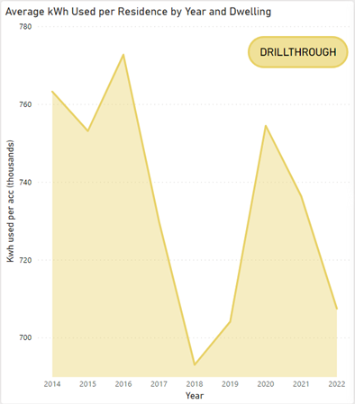

**Dataset**:

[T3.5 Average Monthly Household Electricity Consumption by Planning Area & Dwelling Type](https://www.ema.gov.sg/content/dam/corporate/resources/singapore-energy-statistics/excel/SES_Public_2023_tidy.xlsx.coredownload.xlsx)

**Rationale**:

This graph is to determine if Singaporeans in general are using more or less electricity. Electricity usage has gotten down to around pre-covid time from 704 to 707 thousand kWh. There was a spike in 2019 to 2020 from 704 to 754 thousand kWh due to Covid-19 and has been decreasing steeply in the following years to 707 thousand kWh.

**Interactives**:

Filter by Year, dwelling type, region of Singapore

### 2. Tariff

## 

**Dataset:**

[Historical Electricity Tariff](https://www.spgroup.com.sg/dam/spgroup/docs/our-services/utilities/tariff-information/Historical-Electricity-Tariff--1Q24-Final-.xlsx)

**Rationale:**

For users to see the change of electrical tariff over time.

**Interactives**:

Filter by Year

### 3. Electrical Cost over Time

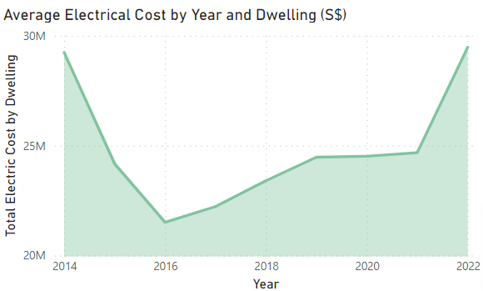

**Dataset:**

[T3.4 Total Household Electricity Consumption by Dwelling Type](https://www.ema.gov.sg/content/dam/corporate/resources/singapore-energy-statistics/excel/SES_Public_2023_tidy.xlsx.coredownload.xlsx)

**Rationale:**

Cost is affected by total electricity used instead of average electricity used. This shows that the trend of the total electricity used over time has been increasing from 2016 to 2022, 14576 and 20017 sgd respectively.

COVID-19 did not change the amount of electricity cost from 2019 to 2021, 16595 to 16766 sgd respectively.

**Interactives**:

Filter by Year, dwelling type, region of Singapore

### 4. Electrical Usage over Time

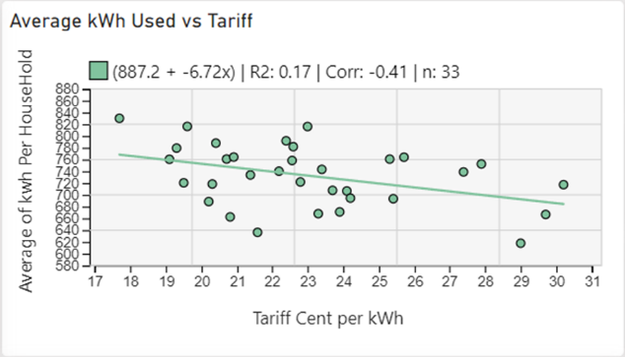

**Datasets:**

[T3.5 Average Monthly Household Electricity Consumption by Planning Area & Dwelling Type](https://www.ema.gov.sg/content/dam/corporate/resources/singapore-energy-statistics/excel/SES_Public_2023_tidy.xlsx.coredownload.xlsx)

[Historical Electricity Tariff](https://www.spgroup.com.sg/dam/spgroup/docs/our-services/utilities/tariff-information/Historical-Electricity-Tariff--1Q24-Final-.xlsx)

**Rationale:**

There is a small negative association between tariff and kWh used. Hence, increasing the tariff would have minor effects.

**Interactives**:

Filter by Year, dwelling type, region of Singapore

### 5. Electrical Cost over Time

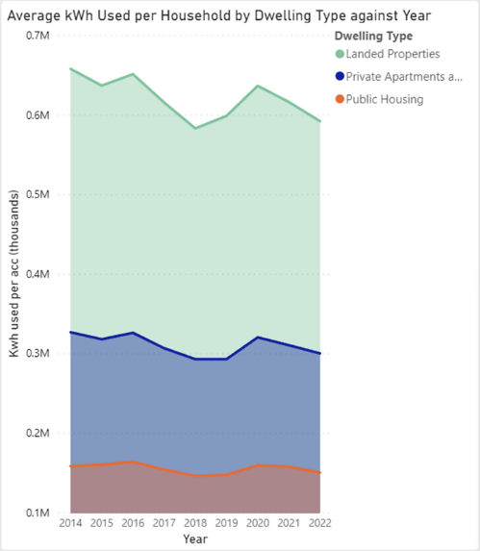

**Dataset:**

[T3.5 Average Monthly Household Electricity Consumption by Planning Area & Dwelling Type](https://www.ema.gov.sg/content/dam/corporate/resources/singapore-energy-statistics/excel/SES_Public_2023_tidy.xlsx.coredownload.xlsx)

**Rationale:**

Overall, electrical usage has decreased from 2014 to 2022 for all dwelling types. Specifically, landed properties in 2014 to 2022 from 657685 to 591878 thousand kWh. 2019 there was a spike overall due to COVID-19 but has been decreasing since pre-covid time.

**Interactives**:

Filter by Year, dwelling type, region of Singapore

### 6. Electrical Usage Month over Month

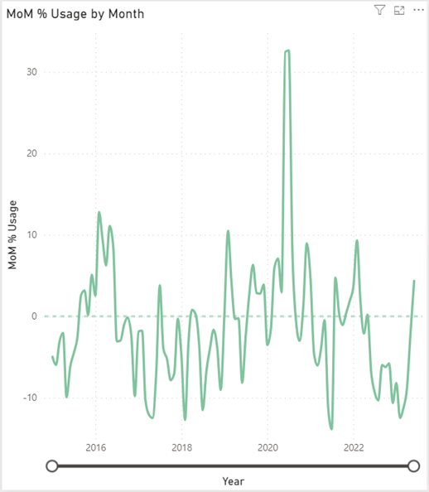

**Dataset:**

[T3.5 Average Monthly Household Electricity Consumption by Planning Area & Dwelling Type](https://www.ema.gov.sg/content/dam/corporate/resources/singapore-energy-statistics/excel/SES_Public_2023_tidy.xlsx.coredownload.xlsx)

**Rationale:**

Electrical usage varies greatly month over month. The highest was 32% in 2020 June and July and the lowest being -13.87% on 2021 July.

**Interactives**:

Filter by Year, dwelling type, region of Singapore

### 7. Breakdown of Electrical Costs over Years

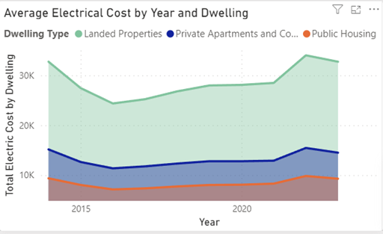

**Datasets:**

[T3.5 Average Monthly Household Electricity Consumption by Planning Area & Dwelling Type](https://www.ema.gov.sg/content/dam/corporate/resources/singapore-energy-statistics/excel/SES_Public_2023_tidy.xlsx.coredownload.xlsx)

[Historical Electricity Tariff](https://www.spgroup.com.sg/dam/spgroup/docs/our-services/utilities/tariff-information/Historical-Electricity-Tariff--1Q24-Final-.xlsx)

**Rationale:**

Overall, electrical costs have been increasing since 2016. The highest cost in 2022 at 34074, 15462, and 9481 for landed, apartments and HBB respectively.

**Interactives**:

Filter by Year, dwelling type, region of Singapore

### 8. Ridership by Year

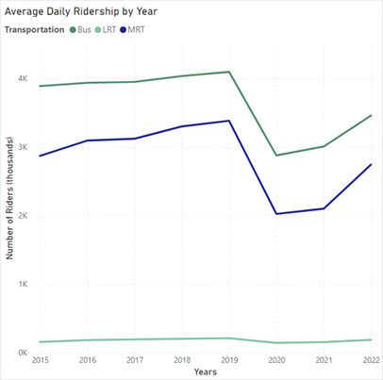

**Dataset**:

[Public Transportation Operation and Ridership](https://tablebuilder.singstat.gov.sg/table/TS/M651351)

**Rationale:**

See the popularity of each type of public transportation over time. 2019 took a hit in ridership due to COVID-19 and has not risen back up to pre-COVID time.

**Interactives**:

Filter by transportation mode.

### 9. Grab Revenue

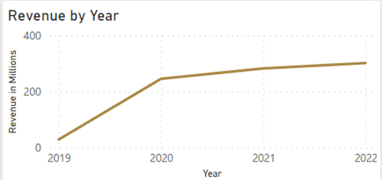

**Dataset:**

[Link (2019-2022) (page 136)](https://investors.grab.com/annual-reports-0);

[Link (2019-2022) (page 132)](https://investors.grab.com/annual-reports-0)

**Rationale:**

From 2019 to 2020, Grab's revenue increased from 30 to 246 million and has been increasing. This is due to Singaporean's reliance on Grab taxis and food delivery during the pandemic and the reliance on Grab has been increasing since the pandemic.

### 10. Total ridership for Public Transportation

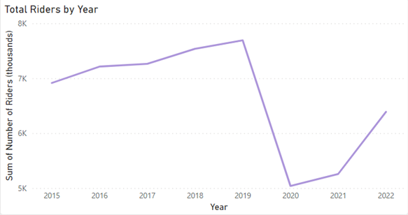

**Dataset:**

[Public Transportation Operation and Ridership](https://tablebuilder.singstat.gov.sg/table/TS/M651351)

**Rationale:**

From 2015 to 2019, overall public transportation ridership has been increasing steadily, from 3601 to 4099 thousand riders. From 2019 to 2020, it dropped to 2878 thousand riders. However, the number of riders did not go back to before covid time.

**Interactives**:

Filter by transportation mode.

### 11. Cars in Singapore over the Years

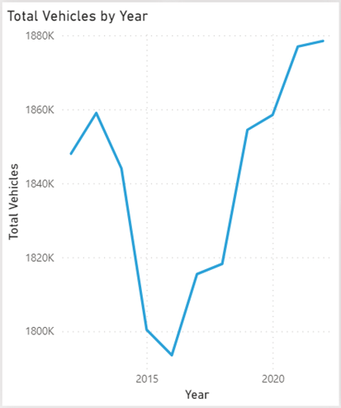

**Dataset:**

[Vehicle Population by Type of Fuel Used (yearly)](https://www.lta.gov.sg/content/dam/ltagov/who_we_are/statistics_and_publications/statistics/pdf/MVP01-4_MVP_by_fuel.pdf)

**Rationale:**

Covid-19 slowed down the increased number of cars in Singapore. From 2018 to 2019, there were 1828 and 1854 thousand cars in Singapore respectively and 1858 thousand cars in Singapore in 2020.

**Interactives**:

Filter by year and public transportation type.

### 12. Non-Renewable Fuel Cars over the Years

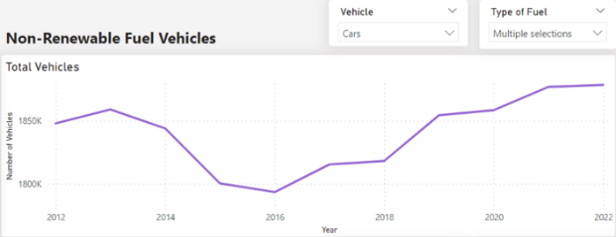

**Dataset**:

[Vehicle Population by Type of Fuel Used (yearly)](https://www.lta.gov.sg/content/dam/ltagov/who_we_are/statistics_and_publications/statistics/pdf/MVP01-4_MVP_by_fuel.pdf)

**Rationale:**

Overall, for non-renewable fuel cars, there has been an increasing number of cars in Singapore. The gradient from 2016 to 2019 is steeper than from 2019 to 2022.

From 2020 to 2022 was the steepest rise in the number of vehicles from 43,632 to 73,534 thousand Hybrid Electric or/and Electric Vehicles. This might be due to the various rebates the government provides for cleaner energy vehicles.

**Interactives**:

Filter by year, type of vehicle, and type of fuel.

### 14. Amount of Electricity used per Section

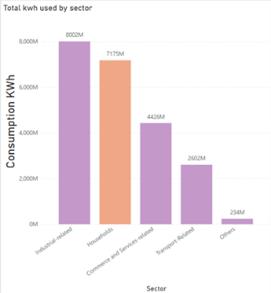

**Dataset:**

[Electricity Consumption by Sub-Sector(Total)](https://www.ema.gov.sg/content/dam/corporate/resources/singapore-energy-statistics/excel/SES_Public_2023_tidy.xlsx.coredownload.xlsx)

**Rationale:**

Solar panels are used in residential and non-residential areas. However, solar panels are aimed at supplying electricity for residents and this graph shows that solar panels are far from sufficient to reach net zero for household electricity consumption.

**Interactives**:

Filter by year.

### 15. Solar Panels Installation

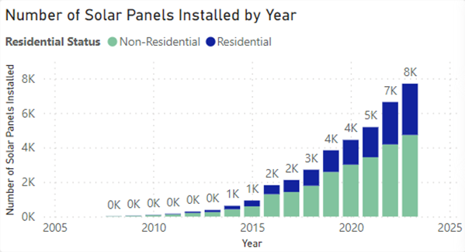

**Dataset:**

[Solar PV Installation by URA Planning Region as of the end of Period](https://www.ema.gov.sg/content/dam/corporate/resources/singapore-energy-statistics/excel/SES_Public_2023_tidy.xlsx.coredownload.xlsx)

**Rationale:**

To show how much the government and Singaporeans invested in solar panels. The highest increase in solar panel installation was from 2021 to 2022, with 5k to 7k solar panels installed.

**Interactives**:

Filter by year, residential status and region.

### 16. Solar Panels Production

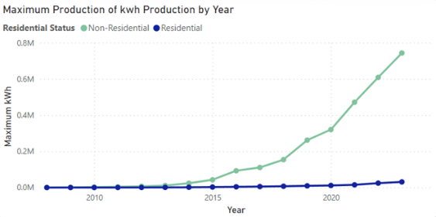

**Dataset:**

[Solar PV Installation by URA Planning Region as of the end of Period](https://www.ema.gov.sg/content/dam/corporate/resources/singapore-energy-statistics/excel/SES_Public_2023_tidy.xlsx.coredownload.xlsx)

**Rationale:**

To show the impact of solar panels. Most solar panel installations are non-residential.

**Interactives**:

Filter by year, residential status and region.

### 17. Average Household Electrical Usage

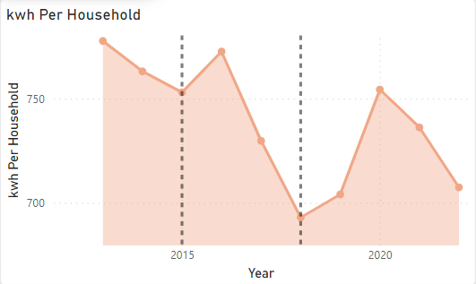

**Dataset:**

[T3.5 Average Monthly Household Electricity Consumption by Planning Area & Dwelling Type](https://www.ema.gov.sg/content/dam/corporate/resources/singapore-energy-statistics/excel/SES_Public_2023_tidy.xlsx.coredownload.xlsx)

**Rationale:**

I use the average as it is not affected by the number of houses in Singapore. However, the steep decrease in electrical usage, 649 to 511 kWh per household from 2015 to 2018 respectively is an anomaly.

### 18. Total Household Electrical Usage

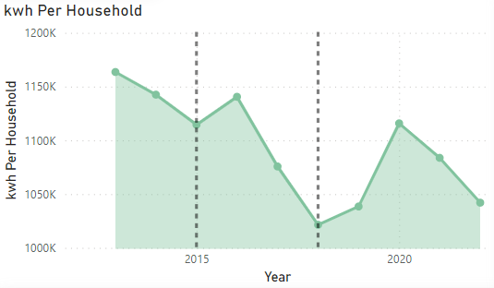

**Dataset:**

[T3.5 Average Monthly Household Electricity Consumption by Planning Area & Dwelling Type](https://www.ema.gov.sg/content/dam/corporate/resources/singapore-energy-statistics/excel/SES_Public_2023_tidy.xlsx.coredownload.xlsx)

**Rationale:**

This shows that although the average electrical usage has been decreasing, the total electrical usage has been increasing. From 2015 to 2018, 1.6 to 1.9 kWh per household respectively.

### 19. Number of Condos and HDB over Years

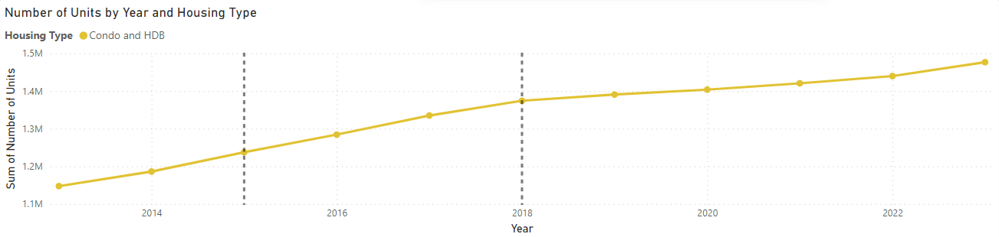 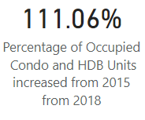

**Dataset:**

[Households](https://www.singstat.gov.sg/find-data/search-by-theme/households/households/latest-data)

**Rationale:**

This shows that from 2015 to 2019, there was a 111% increase in condos and HDB. This might be a reason for the increase in electrical usage but a decrease in average electrical usage as condos and HBD bring down the average electrical usage while landed properties bring the average electrical usage up.

### Sustainable Living | Cheng Sheh Nee – 234745J

|  |
| --- |
| **Sustainable Living Dashboard** |
| **Sub-Hypothesis:**  The Sustainable Living pillar of the Green Plan is committed to building an eco-friendly country. |
|  |

### 1. Waste Management by Waste Type in 2022 – NEA 2022 Waste Statistics

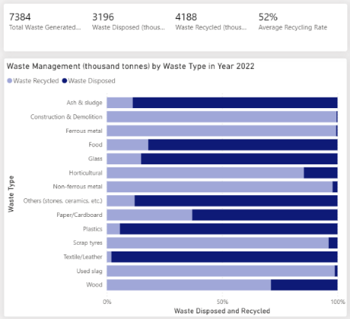 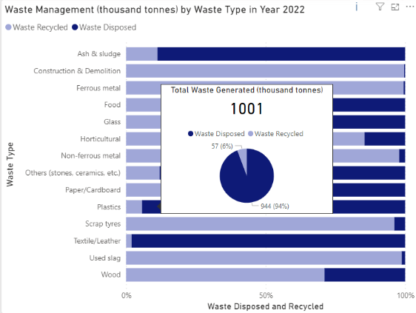

*Y-Axis sorted by waste type in ascending order as the data of total waste generated varies*

**Dataset:**

<https://www.nea.gov.sg/our-services/waste-management/waste-statistics-and-overall-recycling>

**Rationale:**

The bar chart detailing waste management by type in 2022 shows a significant amount of waste being recycled across various categories, from construction materials to food and plastics. With a total of 7,384 thousand tonnes of waste generated and 4,188 thousand tonnes of it recycled, **the average recycling rate is 52%**. The commitment to recycling by the government is evident. Over **half** of the waste generated is being processed for reuse, rather than ending up in landfills.

**Interactives:**

1. Includes a multi-row card to provide an overview of the chart.
2. Tooltip features to display the total waste generated, waste disposed and waste recycled.

### 2. Waste Management (million tonnes) by Year

**Datasets:**

<https://www.statista.com/statistics/628000/waste-disposed-in-singapore/> ;

<https://www.statista.com/statistics/628048/waste-recycled-in-singapore/>

**Rationale:**

The trend analysis from 2013 to 2022 details the volume of domestic and non-domestic waste disposed of alongside recycled waste. It reveals a steady increase in recycling efforts, despite a dip in recycling rates in 2020 of 3.04 million tonnes of waste recycled, likely due to the COVID-19 pandemic, which impacted waste management systems worldwide. However, there's a **visible recovery**, as we can see the total waste recycled increased to 3.83 million tonnes in 2021 and 4.19 million tonnes in 2022. This shows **Singapore's resilience** and **ongoing progress towards its eco-friendly aspirations**.

**Interactives:**

1. Includes two cards to provide an overview of the waste disposed of and waste recycled.
2. Includes a zoom slider (X-axis) to allow users to zoom in on the Year.
3. Tooltip feature to display the year, total waste disposed of, domestic and non-domestic waste disposed and the total waste recycled.

### 3. Recycling Rate by Year and Waste Type (%) – NEA Waste Statistics

**Dataset:**

<https://www.nea.gov.sg/media/news/news/index/waste-generation-and-recycling-rates-increased-in-2022-as-economic-activity-picked-up#:~:text=Overall%2C%20the%20recycling%20rate%20%5B4,12%20per%20cent%20in%202022>

**Rationale:**

The recycling rate for each waste type is **constant**. It illustrates the concept of a **stable** and **effective** **recycling infrastructure** in Singapore. This indicates a **steady level** of recycling efforts and commitment to sustainable waste management practices over time.

**Interactives:**

1. Includes a slicer for the user to filter the data by waste type.
2. Includes a zoom slider (X-axis) to allow users to zoom in on the Year.

## 4. Number of Reverse Vending Machines in Singapore – NEA RVM

**Dataset:**

<https://www.nea.gov.sg/our-services/waste-management/reverse-vending-machines>

**Rationale:**

The pie chart and distribution map of reverse vending machines highlight a **strategic deployment** across Singapore. The role of reverse vending machines, which are automated devices that allow users to return empty beverage containers for **recycling purposes** in exchange for incentives such as vouchers or refunds. The **even distribution** of reverse vending machines provides **greater accessibility** and thus an encouraging factor for citizens to recycle.

**Interactives:**

1. Tooltip feature to display the location and number of reverse vending machines.

## 5. Awareness on Recycling - NEA’s 2023 Survey on Household Recycling

**Dataset:**

<https://www.nea.gov.sg/media/news/news/index/72-per-cent-of-households-recycle-in-2023#:~:text=3%20NEA's%202023%20survey%20on,the%20recycling%20bins%20and%20chutes>

**Rationale:**

The commitment to recycling is further reinforced by public awareness, as indicated by the survey visuals on recycling. The survey question asked was “Which of these items can be put into the blue recycling bin for recycling?”, the blue recycling bin refers to the icon beside the title.

For recyclable items, many people know that rinsed shampoo or detergent bottles can be recycled. In contrast, many people do not know that plastic film or flexible packaging can be recycled.

For non-recyclable items, many people know that unwanted fruit or vegetable parts cannot be recycled, however many people do not know that old clothing cannot be recycled in the blue recycling bin.

These key insights reveal which recyclable items are **most familiar** to the public and which items are **most frequently misclassified**, underscoring the need for **focused public education** in those areas.

**Interactives:**

1. Uses cards to spotlight the most and least recognized items from the survey (employ a Top N analysis).

## 6. Total Waste Generated vs Total Waste Recycled by Waste Type

**Dataset:**

<https://www.nea.gov.sg/media/news/news/index/waste-generation-and-recycling-rates-increased-in-2022-as-economic-activity-picked-up#:~:text=Overall%2C%20the%20recycling%20rate%20%5B4,12%20per%20cent%20in%202022>

**Rationale:**

The linear regression model shows a **strong positive correlation** between total waste generated and total waste recycled, denoted by an R-squared value of 0.59 and a correlation coefficient of 0.77. This reinforces the idea that as Singapore produces waste, there are **proportional efforts to recycle** it, showcasing a proactive approach to waste management, aligning with the objectives of an eco-friendly country.

It supports the sub-hypothesis that the Sustainable Living pillar of the Green Plan is actively working towards eco-friendly practices by **increasing** recycling efforts in response to increased waste generation. Therefore, the data can be seen as providing evidence that the **Green Plan is committed to building an eco-friendly country**.

### Resilient Future | Chong Cheng Hock – 230643M

|  |
| --- |
| **Resilient Future Dashboard** |
| **Sub-Hypothesis:**  The Resilient Future pillar of the Green Plan is committed to making its food supply resilient in the future. |
|  |

1. Food Import Weight Year-over-Year Growth – SFA Annual Report 2021, SFA Annual Report 2022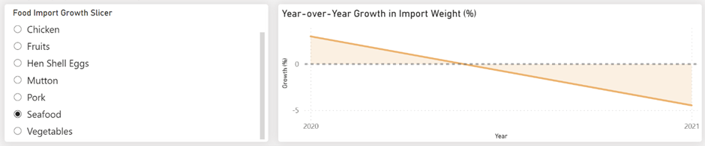**Datasets:**

[SFA | Singapore Food Statistics 2022 Report](https://www.sfa.gov.sg/docs/default-source/publication/sg-food-statistics/singapore-food-statistics-2022.pdf); [SFA | Singapore Food Statistics 2021 Report](https://www.sfa.gov.sg/docs/default-source/publication/sg-food-statistics/singapore-food-statistics-2021.pdf)

**Rationale:**

This shows the year-over-year growth of food imports into Singapore in the years 2020 and 2021.

There is an overall decreasing trend in growth rate from 2020 to 2021, with the only exception of fruits. This shows a decrease in food imports in 2021 as compared to 2020. This is a positive indicator that the government is relying less on food imports and instead investing towards local production to meet the food demand of the population. Therefore, the government is committed to making its food supply resilient.

**Interactives:**

1. Slicer to filter the food import category.

### 2. Hen Shell Egg Local Production vs Imports by Quartiles

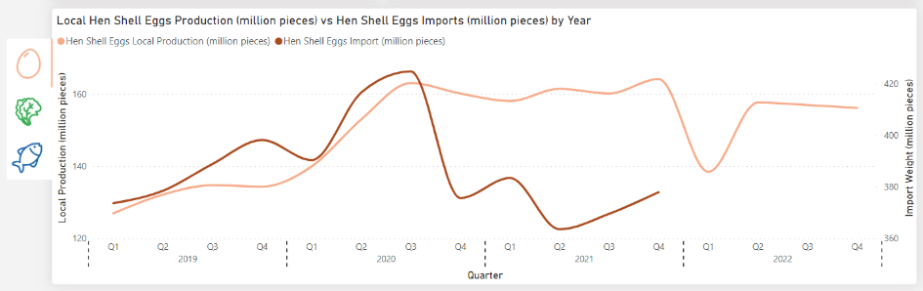

**Datasets:**

[SFA | Singapore Food Statistics 2022 Report](https://www.sfa.gov.sg/docs/default-source/publication/sg-food-statistics/singapore-food-statistics-2022.pdf); [SFA | Singapore Food Statistics 2021 Report](https://www.sfa.gov.sg/docs/default-source/publication/sg-food-statistics/singapore-food-statistics-2021.pdf)

**Rationale:**

Hen shell egg imports dipped in 2021. Local production has no growth in 2021, thus, we can only conclude that there is a shift in consumer demands and not a decreased reliance on food imports. Therefore, the government is not committed to making its food supply resilient.

### 3. Vegetables Local Production vs Imports by Quartiles

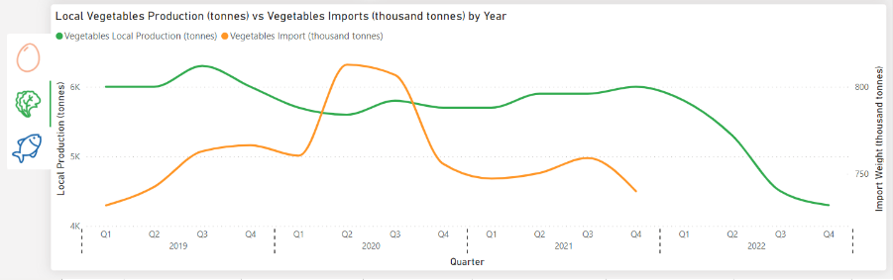

**Datasets:**

[SFA | Singapore Food Statistics 2022 Report](https://www.sfa.gov.sg/docs/default-source/publication/sg-food-statistics/singapore-food-statistics-2022.pdf); [SFA | Singapore Food Statistics 2021 Report](https://www.sfa.gov.sg/docs/default-source/publication/sg-food-statistics/singapore-food-statistics-2021.pdf)

**Rationale:**

Vegetable imports dipped in 2020Q3, with local production only experiencing a slight growth of 300 tonnes in 2021. Thus, we can only conclude that there is a shift in consumer demands and not a decreased reliance on food imports. Therefore, the government is not committed to making its food supply resilient.

### 4. Seafood Local Production vs Imports by Quartiles

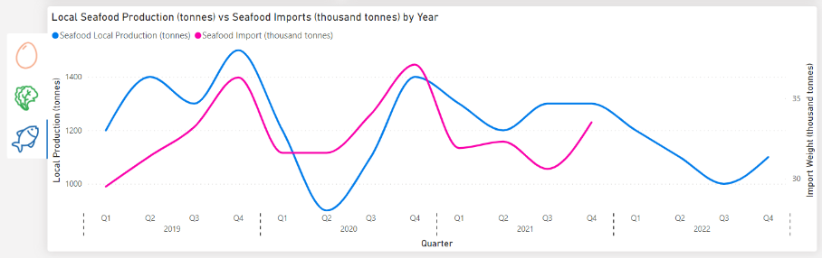

**Datasets:**

[SFA | Singapore Food Statistics 2022 Report](https://www.sfa.gov.sg/docs/default-source/publication/sg-food-statistics/singapore-food-statistics-2022.pdf); [SFA | Singapore Food Statistics 2021 Report](https://www.sfa.gov.sg/docs/default-source/publication/sg-food-statistics/singapore-food-statistics-2021.pdf)

**Rationale:**

Seafood imports fluctuate with similar trends in both 2019 and 2020. However, in 2021Q4, it did not reach the peak in 2020Q4 (same period as last year). Similarly for local production in 2021Q4. Thus, we can only conclude that there is a shift in consumer demands and not a decreased reliance on food imports. Therefore, the government is not committed to making its food supply resilient.

### 5. Food Waste Disposal and Recycling Rates vs GDP by Year

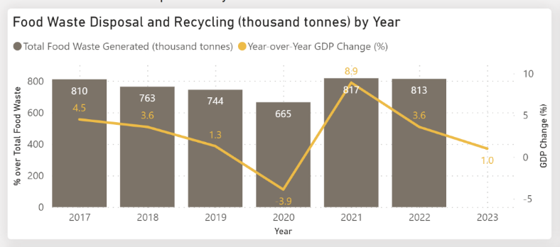

**Datasets:**

[NEA | Wastage and Recycling Statistics 2017-2021](https://www.nea.gov.sg/docs/default-source/default-document-library/waste-and-recycling-statistics-2017-to-2021.pdf); [NEA | Wastage and Recycling Statistics 2022](https://www.nea.gov.sg/our-services/waste-management/3r-programmes-and-resources/food-waste-management);

[International Monetary Fund | Singapore GDP Annual Percent Change](https://www.imf.org/external/datamapper/NGDP_RPCH@WEO/SGP?zoom=SGP&highlight=SGP)

**Rationale:**

There is a positive correlation between food waste generated and year-over-year growth in Singapore’s gross domestic product (GDP). This shows that food waste generated varies with GDP (higher purchasing power -> food is much more accessible). This shows that the government has little control over the food wastage situation and thus a lack of action from the government. There is room for improvement in terms of raising awareness on food wastage such as through educational campaigns to educate and persuade the public. Thus, the government is not committed to building a resilient food supply in the future.

**Statistical model**:

simple correlation relationship.  
- plotted food waste as bar charts, GDP growth per annum as line chart.  
- positive correlation relationship observed where an increase in GDP growth also resulted in an increase in food waste.

**Interactives**:

Tooltip features a report page to display the recycling rate within the trash disposed – a small tidbit of information on NEA’s effort to mitigate the food waste issue.

### 6. Agriculture Orientation Index of Various Countries by Year

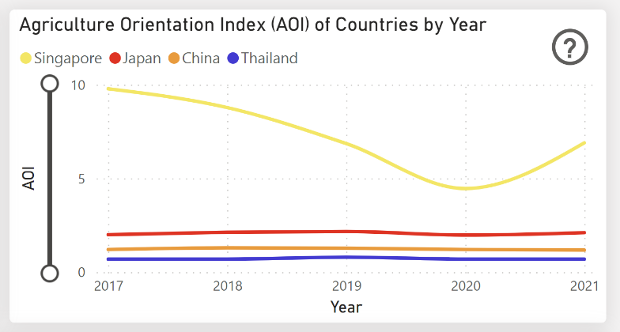

**Dataset:**

[ADB | The Agriculture Orientation Index for Government Expenditure](https://kidb.adb.org/explore?filter%5Bindicator_id%5D=3020009&filter%5Beconomy_code%5D=AFG%2CARM%2CAUS%2CAZE%2CBAN%2CBHU%2CBRU%2CCAM%2CCOO%2CFIJ%2CFSM%2CGEO%2CHKG%2CIND%2CINO%2CJPN%2CKAZ%2CKGZ%2CKIR%2CKOR%2CLAO%2CMAL%2CMLD%2CMON%2CMYA%2CNAU%2CNEP%2CNIU%2CNZL%2CPAK%2CPHI%2CPLW%2CPNG%2CPRC%2CRMI%2CSAM%2CSIN%2CSOL%2CSRI%2CTAJ%2CTAP%2CTHA%2CTIM%2CTKM%2CTON%2CTUV%2CUZB%2CVAN%2CVIE&filter%5Byear%5D=2000%2C2001%2C2002%2C2003%2C2004%2C2005%2C2006%2C2007%2C2008%2C2009%2C2010%2C2011%2C2012%2C2013%2C2014%2C2015%2C2016%2C2017%2C2018%2C2019%2C2020%2C2021%2C2022%2C2023&grouping=indicators&showRegions=1)

**Rationale:**

The agriculture orientation index (AOI) is a direct measure of how invested a country is into its agriculture sector. It is the ratio of investment against the country’s GDP. It increased to 6.9 in 2021, showing that the government re-prioritising funds back into agriculture.

A higher AOI means greater financial support by the government. This will allow more funds to be channelled into more opportunities for research and development and upscaling of the workforce. Thus, the government is committed to making its food supply resilient in the future.

**Interactives**:

1) Includes a zoom slider for the vertical axis to allow users to zoom in on countries with a smaller data range.

### 7. Local Food Production Weight by Quarter

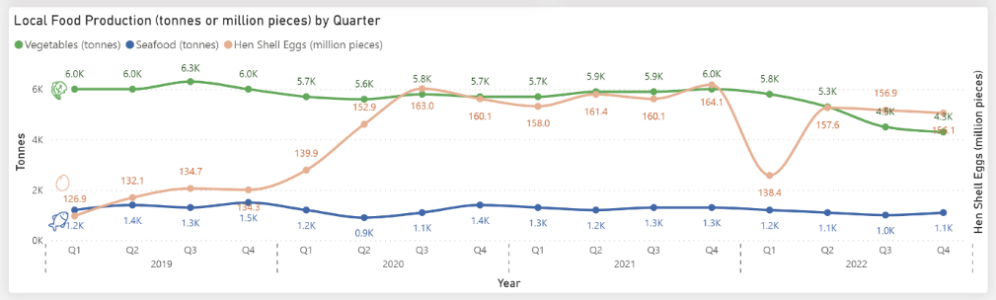

**Datasets:**

[SFA | Singapore Food Statistics 2022 Report](https://www.sfa.gov.sg/docs/default-source/publication/sg-food-statistics/singapore-food-statistics-2022.pdf); [SFA | Singapore Food Statistics 2021 Report](https://www.sfa.gov.sg/docs/default-source/publication/sg-food-statistics/singapore-food-statistics-2021.pdf)

**Rationale:**

Food production has remained relatively stable, with hen shell eggs taking a hit in 2022Q1, but it recovered quickly in subsequent quarters. However, vegetable production has experienced little to no growth with a decrease in 2022. The reason for the decreased vegetable production is inconclusive. Therefore, the government is committed to building a resilient food supply in the future, slowly but surely.

### 8. Licensed Local Farms by Year

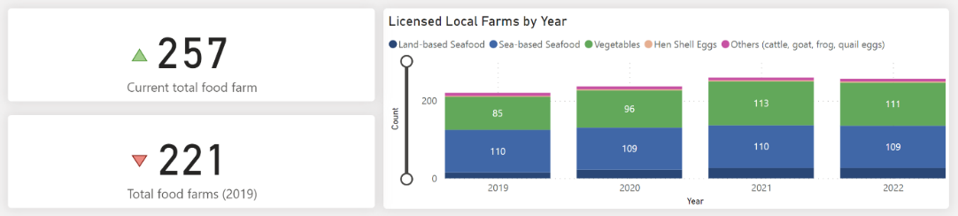

**Dataset:**

[DOS | SingStat Table Builder – Licensed Local Food Farms](https://tablebuilder.singstat.gov.sg/table/TS/M891471)

**Rationale:**

There is an increase of 36 food farms total from 2019 to 2022. This shows commitment to scaling the local farms horizontally and hopefully increased production in local produce. Therefore, the government is committed to making its food supply resilient in the future.

**Statistical model:**

start-end comparisons.  
- shows the differences in farm count between now and 2019.

### 9. Hen Shell Eggs Average Output per Farm by Year

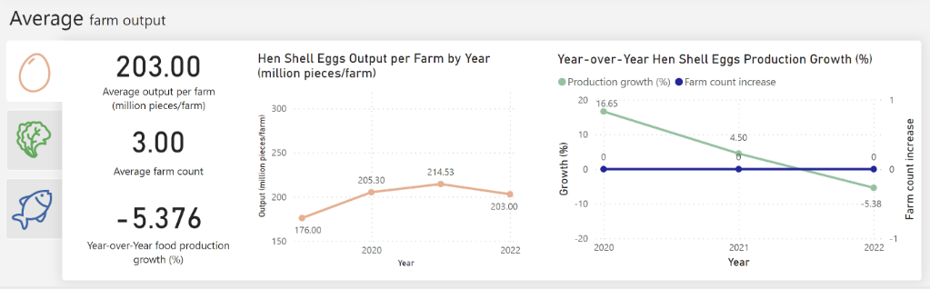

**Dataset:**

[SFA | Singapore Food Statistics 2022 Report](https://www.sfa.gov.sg/docs/default-source/publication/sg-food-statistics/singapore-food-statistics-2022.pdf); [SFA | Singapore Food Statistics 2021 Report](https://www.sfa.gov.sg/docs/default-source/publication/sg-food-statistics/singapore-food-statistics-2021.pdf);

[DOS | SingStat Table Builder – Licensed Local Food Farms](https://tablebuilder.singstat.gov.sg/table/TS/M891471)

**Rationale:**

Hen shell egg production per farm has been increasing well with no changes in its farm count throughout the 4 years. Yet, production growth is decreasing with it crossing the negatives in 2022. This could be caused by the earlier-identified Newcastle disease outbreak which it impacted production in the first quartile of 2022, where production quickly stabilised in the subsequent quartiles. Therefore, the government is committed to building a resilient food supply in the future.

**Statistical model:**  
1) average per unit by year.  
- took the total production of hen shell eggs (in million pieces) by year and divided it against the hen shell egg farm count for that year.

2) year-over-year growth, year-over-year changes.  
- production growth calculated as a year-over-year difference, presented as a percentage; shows the decrease in production over the years.  
- farm count modelled as difference year over year, presented as a single unit; shows the horizontal scaling of hen shell eggs farms in Singapore.

### 10. Vegetables Average Output per Farm by Year

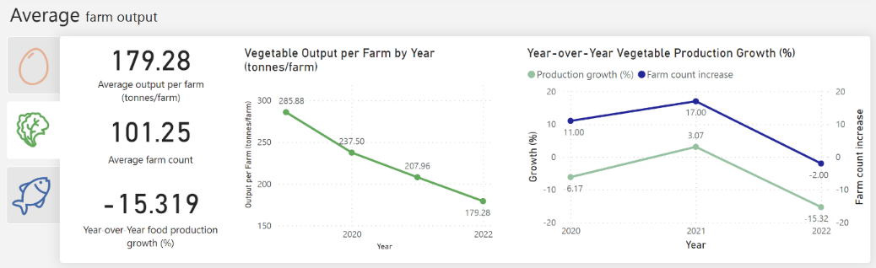

**Dataset:**

[SFA | Singapore Food Statistics 2022 Report](https://www.sfa.gov.sg/docs/default-source/publication/sg-food-statistics/singapore-food-statistics-2022.pdf); [SFA | Singapore Food Statistics 2021 Report](https://www.sfa.gov.sg/docs/default-source/publication/sg-food-statistics/singapore-food-statistics-2021.pdf);

[DOS | SingStat Table Builder – Licensed Local Food Farms](https://tablebuilder.singstat.gov.sg/table/TS/M891471)

**Rationale:**

Vegetable production has a steep decrease from 285 to 179 tonnes per farm from 2019 to 2022. This is despite the increasing number of vegetable farms. There is growth in vegetable production in 2021 but that is after a decrease in 2020. This shows that the increased farm counts do not help increase food output and it only drags down the average farm production. Therefore, the government is not committed enough to building a resilient food supply in the future.

### 11. Seafood Average Output per Farm by Year

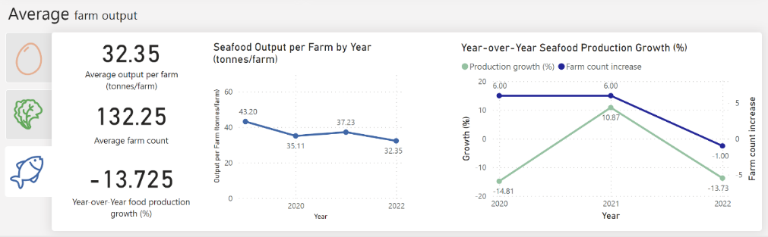

**Dataset:**

[SFA | Singapore Food Statistics 2022 Report](https://www.sfa.gov.sg/docs/default-source/publication/sg-food-statistics/singapore-food-statistics-2022.pdf); [SFA | Singapore Food Statistics 2021 Report](https://www.sfa.gov.sg/docs/default-source/publication/sg-food-statistics/singapore-food-statistics-2021.pdf);

[DOS | SingStat Table Builder – Licensed Local Food Farms](https://tablebuilder.singstat.gov.sg/table/TS/M891471)

**Rationale:**

Seafood production per farm fluctuates but is on a decreasing trend, from 43 to 32 tonnes per farm from 2019 to 2022. In 2021, seafood production per farm does the best as compared to adjacent years. Production has a 10% growth in 2021, however, that is also after a sharp decrease in 2020. The addition of 6 new seafood farms in both 2020 and 2021 did not help with seafood production in 2022. Therefore, paired with the vegetable farm count data, it is a key indicator that new farms take too long to upscale food production. This shines a light on the lack of technology harnessing capabilities where farms are not able to harness new technology to quickly upscale their food production. Therefore, the government is not committed enough to building a resilient food supply in the future.

**4. Iteration Log**

Throughout the project, we refined our report and visualisations countless amounts of times. Below illustrate a few of the revisions we wanted to showcase.

|  |  |
| --- | --- |
| **Homepage – 1st Iteration** | |
| **Before** | **After** |
|  |  |

|  |  |
| --- | --- |
| **Homepage – Final Iteration** | |
| **Before** | **After** |
|  |  |

### City in Nature – Tze Hsuen

|  |  |
| --- | --- |
| **Nature Parks Page – Final Iteration** | |
| **Before** | **After** |
|  |  |

### Energy Reset – Teagan

|  |  |
| --- | --- |
|  | |
| **Before** | **After** |
|  |  |

### Sustainable Living – Sheh Nee

|  |  |
| --- | --- |
| **Awareness on Recycling Page – Final Iteration** | |
| **Before** | **After** |
|  |  |

### Resilient Future – Cheng Hock

|  |  |
| --- | --- |
| **Food Imports Page – Final Iteration** | |
| **Before** | **After** |
|  |  |

# 5. Problems Encountered

**Sourcing for credible data sources:** Acquiring credible datasets was primarily our major challenge as the recommended sources given were insufficient. We required more data on indicators that could only be found by delving further into governmental agencies’ annual reports, namely NParks, NEA, SES and SFA.

**Standardise Layout:** Everyone had a different visual layout for each report design, which presented a challenge when integrating. Compromises had to be made by team members and a common style was derived to aesthetically fit all our report pages.

# 6. Future Enhancements

**Include all the five pillars:** Rather than focusing solely on four pillars, we would cover all five pillars of the Green Plan 2030. Including all the five pillars offers a more comprehensive overview of the entire project.

**Implementation of a mobile view report:** Introducing a mobile view option will enhance accessibility and convenience for stakeholders. By designing a user-friendly interface tailored for mobile devices, we can enhance our stakeholder's experience and foster greater engagement with the project.

**Integration of real-time data:** Integrating real-time data into PowerBI will provide stakeholders with more timely and accurate information, thereby enhancing the overall quality of the project.

# 7. Conclusion

Singapore is a resourceful country with ambitious goals. The Singapore Green Plan 2030 is one of the key drivers in displaying Singapore’s efforts to build a sustainable future.

With the varying metrics, we can conclude that Singapore is committed to developing a sustainable future. However, it is also important to acknowledge the under-performing areas where the government can put more effort into.

# 8. Recommendations

## City in Nature

The clustering of regional parks predominately in the north and central regions, indicates an uneven distribution of regional parks throughout Singapore. This highlights an area for improvement where the government can consider working towards achieving a more balanced allocation of these green areas in each region. This goal aims to ensure citizens in each region will be able to have access and enjoy those nearby regional parks.

## Energy Reset

There has been a steep increase in hybrid and electrical vehicles, but it is still very insignificant compared to the amount of non-renewable fuel vehicles in Singapore. The ratio being more than 100 to 1. To increase more electric and hybrid electric cars, the government can introduce a new and cheaper COE category for electric or hybrid electric cars. Having more electric cars would create a higher demand for electric plugs and hence more electric plugs around Singapore, creating electrical car plug-ins more feasible.

## Sustainable Living

It is recommended to have stricter regulations on single-use plastics and materials that are not recyclable. Concurrently, instead of imposing additional charges for plastic bags or disposable containers and cutlery, a more effective approach would be to provide customers with recyclable bags and reusable containers accompanied by a set of cutleries (with or without extra chargers). This strategy encourages people to opt for reusable items over single-use materials, thus promoting a habit of bringing their bags, containers, and cutlery for future use.

## Resilient Future

Instead of solely focusing on the research and development of farming techniques, government agencies can work closely with farmers to understand day-to-day operations on a higher level. This can allow them to help introduce plans to integrate existing farming technologies into new farms, allowing for a shorter transient period. Ideally, new farms should produce a large, stable output within their first batch.